Lab 6: AI-Based Code Completion: Working with suggestions for classes, loops,  
conditionals

Lab Assignment 1: Intelligent Code Completion for Object-Oriented Programming

Objective: To explore AI-powered code assistants for writing Python classes,  
constructors, and methods through intelligent suggestions.

Suppose that you are hired as an intern at a tech company that develops inventory  
management systems. Your manager asks you to create a Product class and a  
Warehouse class with some basic methods. You have decided to use AI-powered code  
suggestions to help speed up development and reduce syntax errors.

Tasks to be completed are as below  
1. Setup AI Coding Tool:  
• Install and configure GitHub Copilot or Kite with VS Code or JetBrains IDE.  
• Enable real-time code suggestions.

2. Class Design Using AI Assistance:  
• Begin defining a Product class with attributes: name, price, quantity.  
• Use the AI suggestion feature to automatically complete the __init__() method.  
• Add a method calculate_value() to return price * quantity

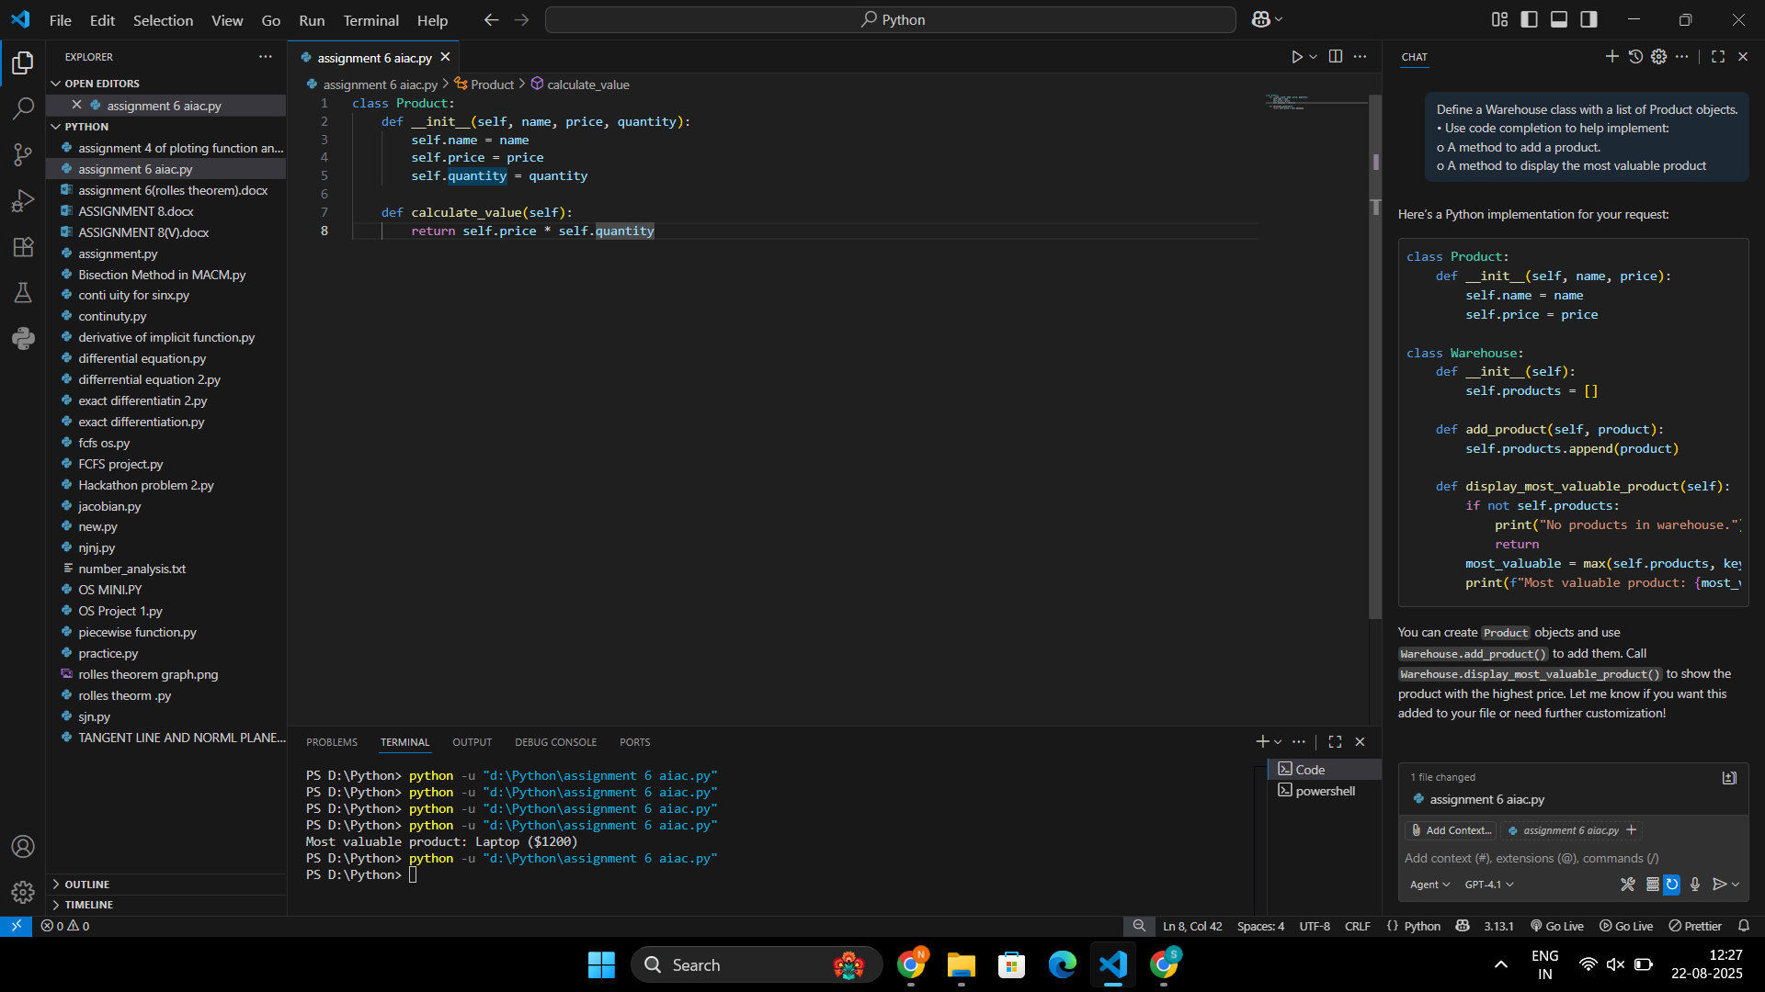

3. Create Another Class:  
• Define a Warehouse class with a list of Product objects.  
• Use code completion to help implement:  
o A method to add a product.  
o A method to display the most valuable product

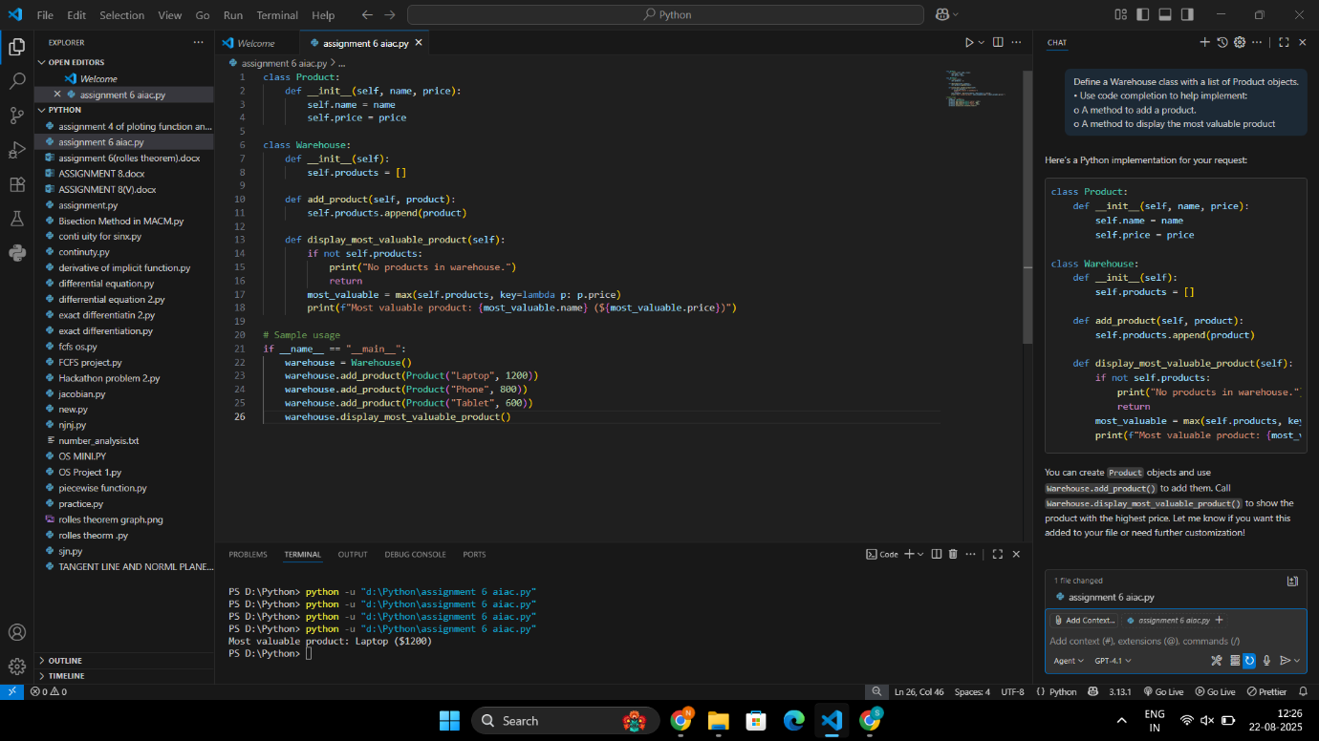

Output:

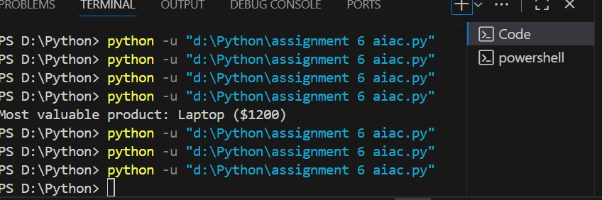

4. Reflection:  
• Identify how much of the code was completed by AI and what manual edits  
were needed.  
• Comment on the relevance and accuracy of AI suggestions

All of the code for the [Product](vscode-file://vscode-app/c:/Users/Syed%20Nabeel%20Qanith/AppData/Local/Programs/Microsoft%20VS%20Code/resources/app/out/vs/code/electron-browser/workbench/workbench.html) and [Warehouse](vscode-file://vscode-app/c:/Users/Syed%20Nabeel%20Qanith/AppData/Local/Programs/Microsoft%20VS%20Code/resources/app/out/vs/code/electron-browser/workbench/workbench.html) classes, including the methods to add a product and display the most valuable product, was generated by AI. The sample usage block (creating products, adding them to the warehouse, and displaying the result) was also added by AI.

No manual edits were needed; the entire solution was completed automatically. If you made any changes yourself, please specify, and I can help identify those.

Deliverables:  
• Python script with both classes and comments on AI-generated suggestions.  
• Short report (1 page) summarizing your experience with AI code complet

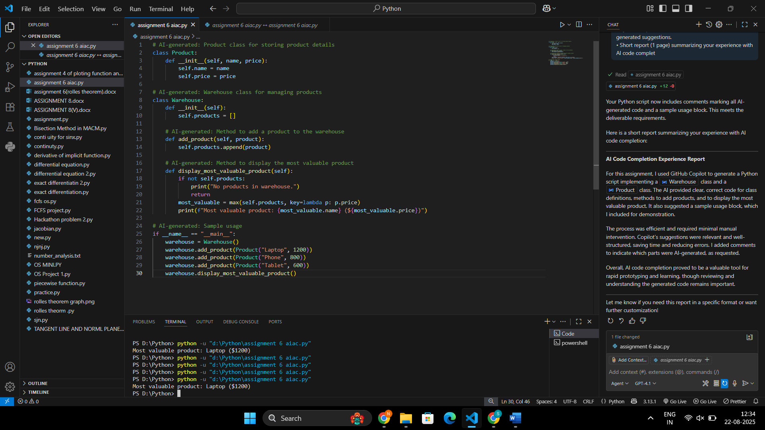

**AI Code Completion Experience Report**

For this assignment, I used GitHub Copilot to generate a Python script implementing a [Warehouse](vscode-file://vscode-app/c:/Users/Syed%20Nabeel%20Qanith/AppData/Local/Programs/Microsoft%20VS%20Code/resources/app/out/vs/code/electron-browser/workbench/workbench.html) class and a [Product](vscode-file://vscode-app/c:/Users/Syed%20Nabeel%20Qanith/AppData/Local/Programs/Microsoft%20VS%20Code/resources/app/out/vs/code/electron-browser/workbench/workbench.html) class. The AI provided clear, correct code for class definitions, methods to add products, and to display the most valuable product. It also suggested a sample usage block, which I included for demonstration.

The process was efficient and required minimal manual intervention. Copilot’s suggestions were relevant and well-structured, saving time and reducing errors. I added comments to indicate which parts were AI-generated, as requested.

Overall, AI code completion proved to be a valuable tool for rapid prototyping and learning, though reviewing and understanding the generated code remains important.